VERSION CONTROL WITH GIT
PRACTICAL 1:
TO UNDERSTAND THE CONCEPT OF VERSION CONTROL, ITS IMPORTANCE IN MANAGING PROJECT CHANGES AND EXPLORE DIFFERENT VERSION CONTROL SYSTEMS.

VERSION CONTROL IS A SYSTEM THAT RECORDS CHANGES TO FILES OVER TIME SO YOU CAN RECALL SPECIFIC VERSION LATER. ITS MOST COMMANLY USED IN SOFTWARE DEVELOPMENT, BUT ITS ALSO VALUABLE FOR MANAGING DOCUMENTS, DESIGNN, AND ANY COLLABORATIVE PROJECT.
KEY FUNCTION:
- TACKS EVERY CHANGES MADE TO A FILE
- ALLOW MULTIPLE PEOPLE TO WORK ON THE SAME PROJECT WITHOUT CONFLICT.
- ENABLES REVERTING TO PREVIOUS VERSION IF NEEDED
- MAINTAINS A HISTORY OF WHO CHANGES WHAT AND WHEN
TYPES OF VERSION CONTROL
- LOCAL VERSION CONTROL SYSTEMS (LOCAL VCS)
A LOCAL VERSION CONTROL SYSTEMS OPERATES ENTIERILY ON YOUR PERSONAL MACHINE WITHOUT ANY CONNECTION TO A REMOTE REPOSITORY. ALL CHANGES AND VERSION HISTORY ARE STORED IN A LOCAL DATABSE ON YOUR COMPUTER.

- CENTRALIZED VERSION CONTROL SYSTEM

IN A CENTRALIZED VERSION CONTROL SYSTEM, ALL THE FILES AND THEIR VERSION HISTORY ARE STORED IN A SINGLE CENTRAL SERVER. THIS SERVER ACTS AS THE MAIN SOURCE FOR THE ENTIRE PROJECT. DEVELOPERS CONNECT TO THIS SERVER TO ACCESS OR MODIFY FILES BUT THEY DO NOT MAINTAIN A FULL LOCAL COPY OF THE PORJECT, INSTEAD THEY WORK WITH THE MOST RECENT VERSION PULLED FROM THE SERVER.

- DISTRIBUTED VERSION CONTROL SYSTEMS

IN DISTRIBUTED VERSION CONTROL SYSTEMS CONTQAINS MULTIPLE REPOSITORIES. EACH USER HAS THEIR OWN REPOSITORY AND WORKING COPY. JUST COMMITTING YOUR CHANE SWILL NOT GIVE OTHER ACCESS TO YOUR CHANGES. THIS IS BECAUSE COMMIT WILL REFLECT THOSE CHANGES IN YOUR LOCAL REPOSITORY AND YOU NEED TO PUSH THEM IN ORDER TO MAKE THEM VISIBLE ON THE CENTRAL REPOSITORY.

PRACTICAL 2
SETUP GIT ON WINDOW SYSTEM , CONFIGURE GIT FOR THE FIRST TIME AND UNDERTAND THE BASIC CONFIGURATION OPTIONS

INSTALL GIT BASH AND VERIFY VERSION : git –version
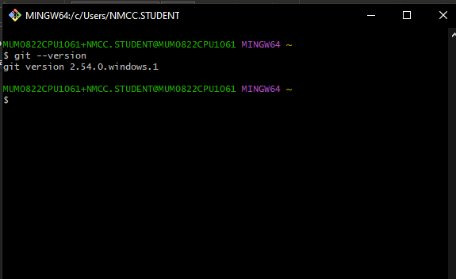
CONFIGURE WITH USERNAME, EMIAL, AND DEFAULT EDITIOR:
git config –global user.name “Parth2350”
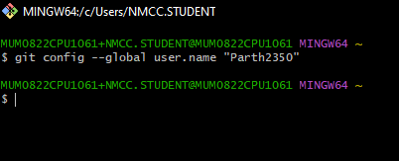
git config –global user.email parthdankhra5@gmail.com
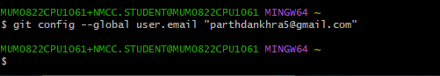
git config –global core.editor “code --wait” 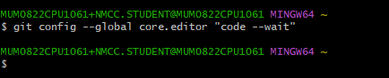

git config –global –list
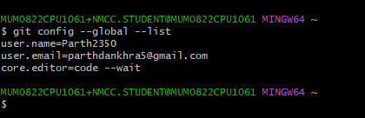
notepad ~/.gitconfig
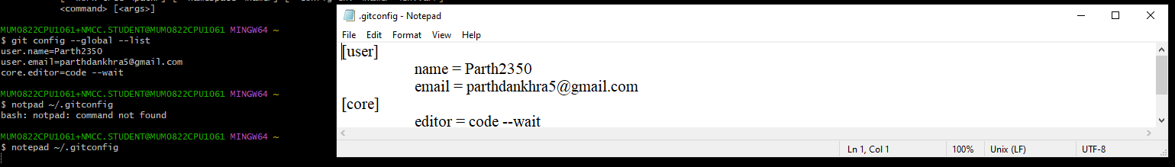

PRATICAL 3
TO EXPLORE GIT HUB AS CLOUD-BASED HOISTING PLATFORM FOR GIT REPOSITORIES AND UNDERSTAND ITS FEATURES AND BENEFITS FOR COLLABORATION AND PORJECT MANAGEMENT
SSH:- SECURESHELL
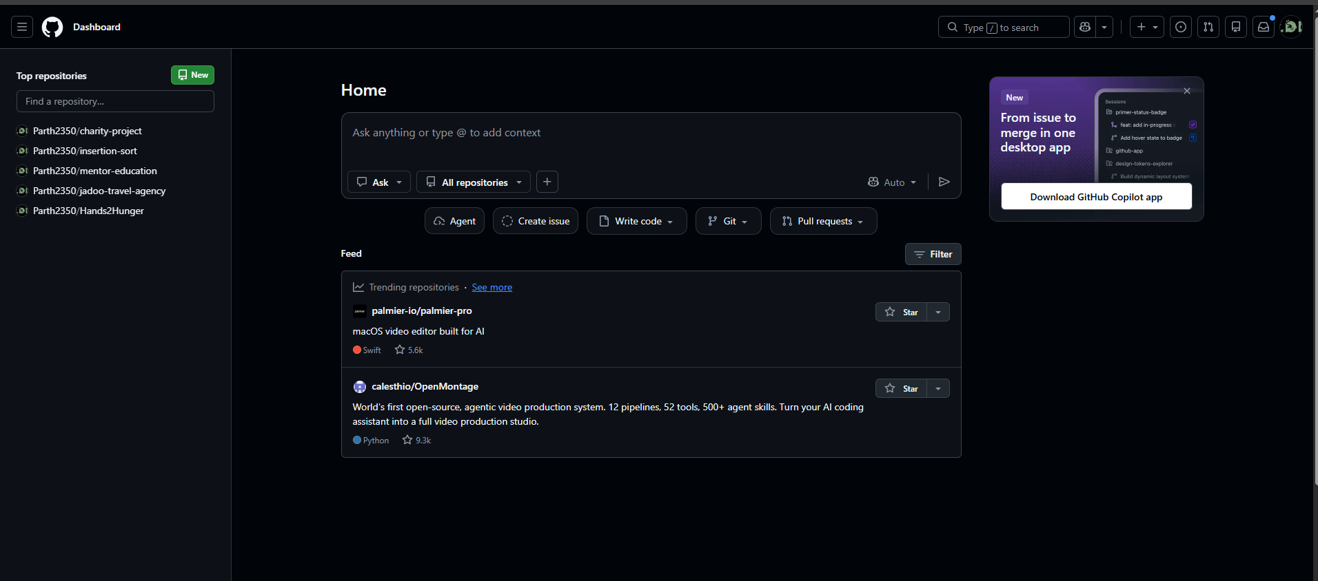
ssh-keygen -t ed25519 -C “parthdankhra5@gmail.com”
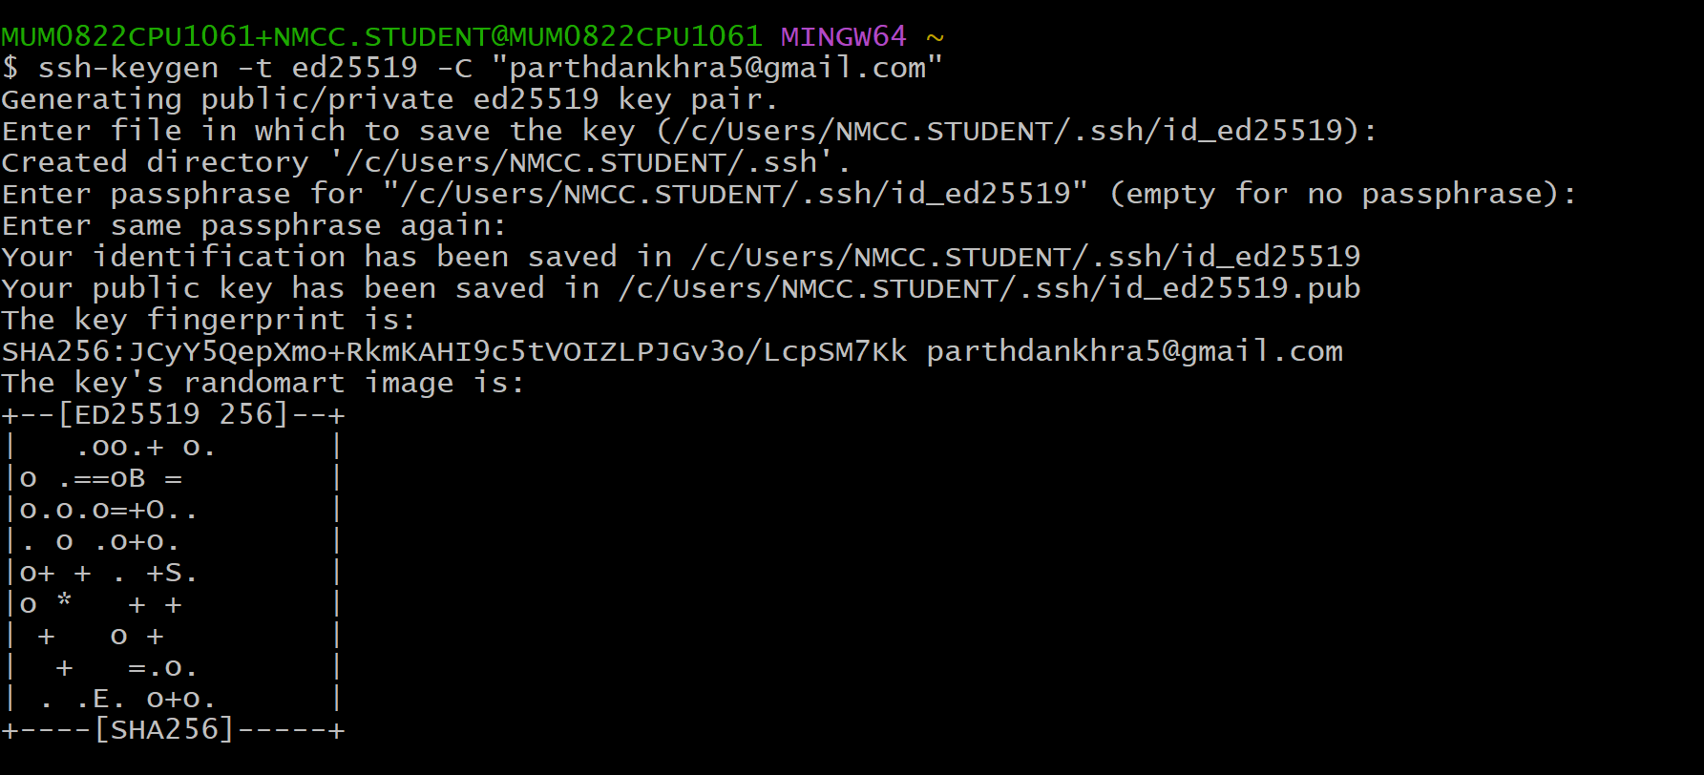
$ eval $(ssh-agent -s)
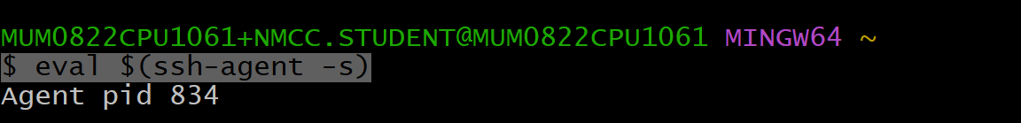
$ ssh-add ~/.ssh/id_ed25519

$ cat ~/.ssh/id_ed25519.pub
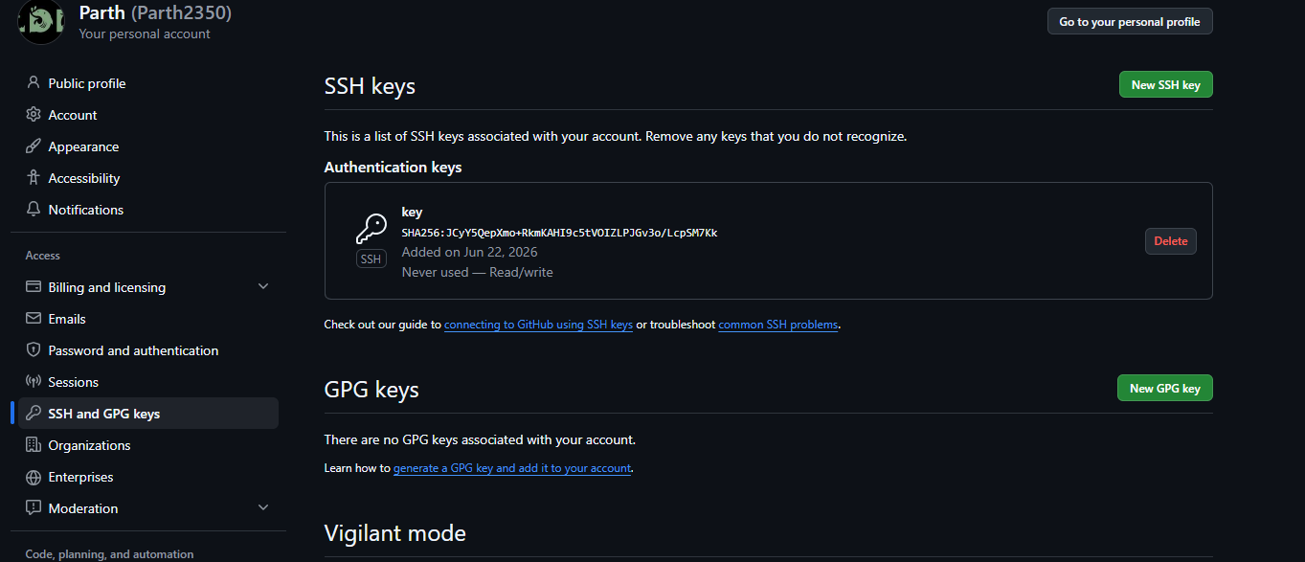
PRACTICAL 4
TO UNDERSTAND THE CONCEPT OF A GIT REPOSITORY AND LEARN TO CREATE AND INITIALIZE A NEW LOCAL REPOSITORY FOR TRACKING PROJECT FILES

CREATE A NEW REMOTE REPOSITORY USING GIT HUB
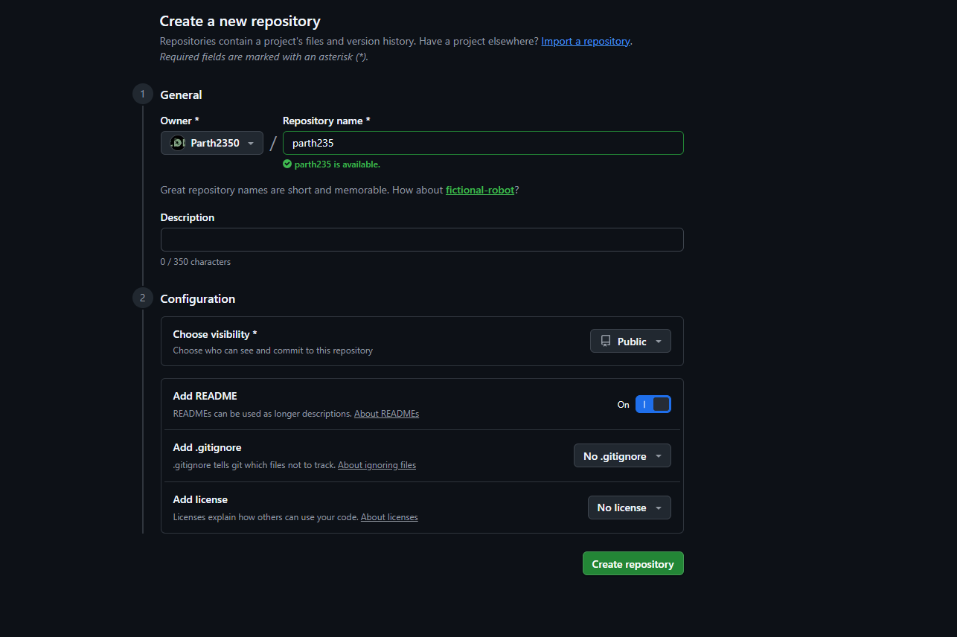

CREATE NEW LOCAL REPOSITORY USING GIT INIT
